RC tutorial 401 – Speed boards in tunnel

=================================

Revised 2022-11-26

* This tutorial's goal is to teach you about 3D with text, offset, rotation and pole routing.
* Assumed RailCOMPLETE skills: Basic knowledge about 3D and object creation in RailCOMPLETE. Familiar with ACS (see tutorial dedicated to ACS).
* Assumed railway skills: None.
* Time to spend here: 30 minutes.
* Further reading: “2021-01-08 002 Instruction manual - 3D modelling with RailCOMPLETE.pdf” and “2021-05-23_001 EN Introduction to RailCOMPLETE v2021.0”, which can be downloaded from our web pages.
* Notice to users with non-English versions of AutoCAD – see footnote[1].
* This tutorial was prepared using software release 2022.2.0.8 with Norwegian DNA version “NO-BN 2021.a (patch 1)”,” 2021-11-27T21:11:27+01:00;2021.a”.

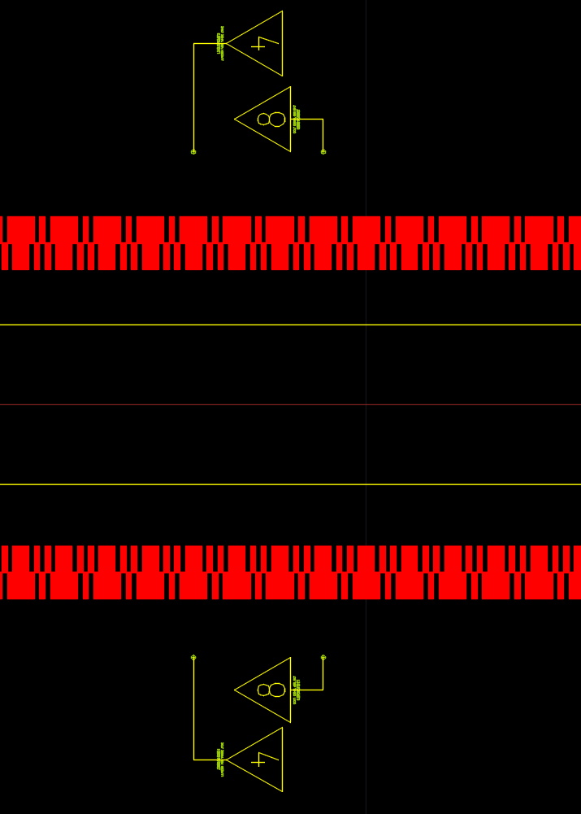

1. Start AutoCAD with RailCOMPLETE, then open the ‘National Tutorials’ folder and locate the DWG file named after this tutorial. You can either type **RC-OpenNationalTutorialsFolder** or you can locate the button below the RC logo in the upper left corner of your AutoCAD window. There are two DWG files – one is the start of the tutorial, the other shows the state you shall have reached at the end of the tutorial.

2. Hover over the top left corner of your modelspace screen to access visual style controls. Set rendering to ‘Hidden’ or ‘Shaded with edges’. In the RC-Settings menu, check ‘Show Intrinsic Property Names’ – otherwise the object’s properties will be shown in the DNA’s local language.  
 

## The speed board displays its speed as currently defined in the database

3. Select all objects (**Ctrl+A** or command **_AI_SELALL**). Activate the 3D preview tool , then navigate in 3D using command **_3DORBIT**, or hold down the Shift key while pressing the middle mouse button and navigating. With all objects selected, right-click and select ‘RailCOMPLETE Annotation -> Copy Annotations to Drawing’.  
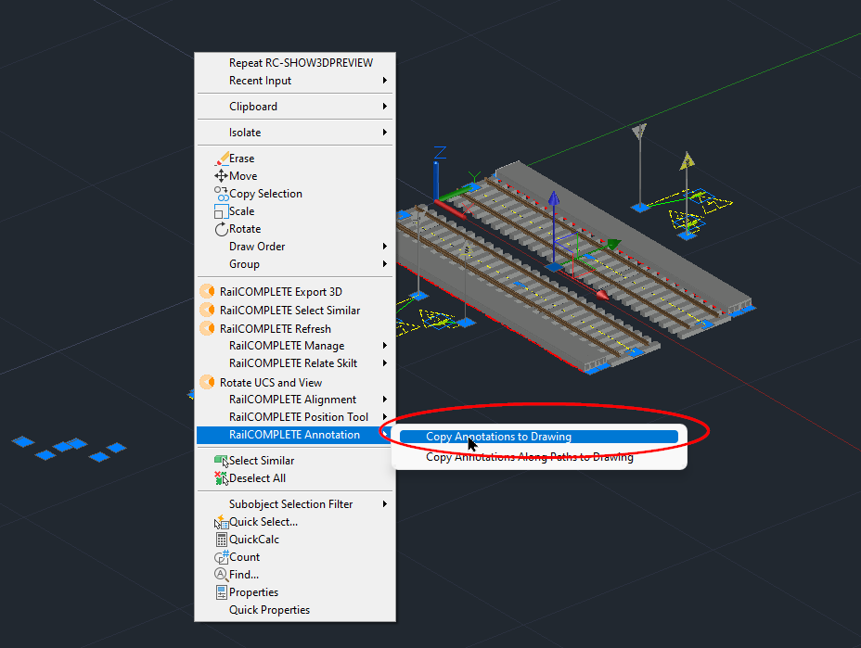

4. Start **RC-ManageProperties** and open the “Linear placement” tab (Norw: ‘Plassering langs linje’). The four speed boards are located at +/-4 meters from their own alignments (Track-Left / Track-Right).  
  
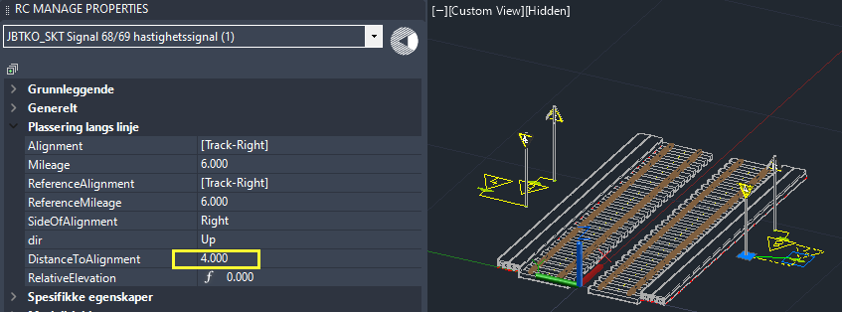

5. Open the ‘Specific properties’ tab (Norw: ‘Spesifikke egenskaper’). The speed board’s ‘SignSpeed’ property is 40 km/h. Since a Norwegian speed board of type ‘68A’ neither shows a ‘plus’ speed (+5) nor a tilting train speed (160), you will only see the ‘4’ on the board’s 2D symbol and 3D rendering.  
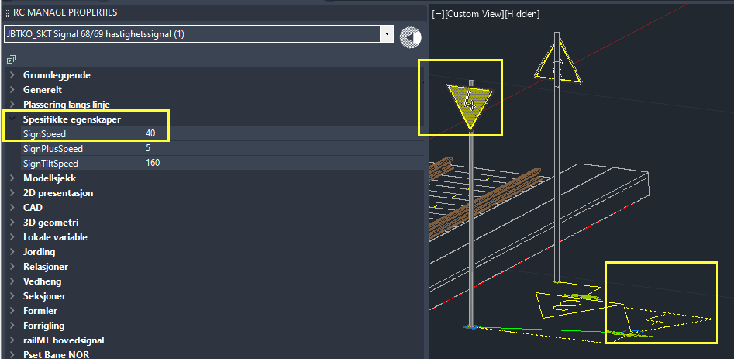

6. The DNA contains a formula that divides SignSpeed by ten, rounds down to the nearest multiple of five, and transfers the result as text to an AutoCAD entity of type ATTDEF being named ‘T01’. The ‘T01’ ATTDEF is contained in the external 3D library file “NO-BN-3D-KO-SKT-SKILT-68A-NEDSATT-KJØREHASTIGHET”. All this leads to the ‘4’ digit being shown in the 3D preview / 3D export.  
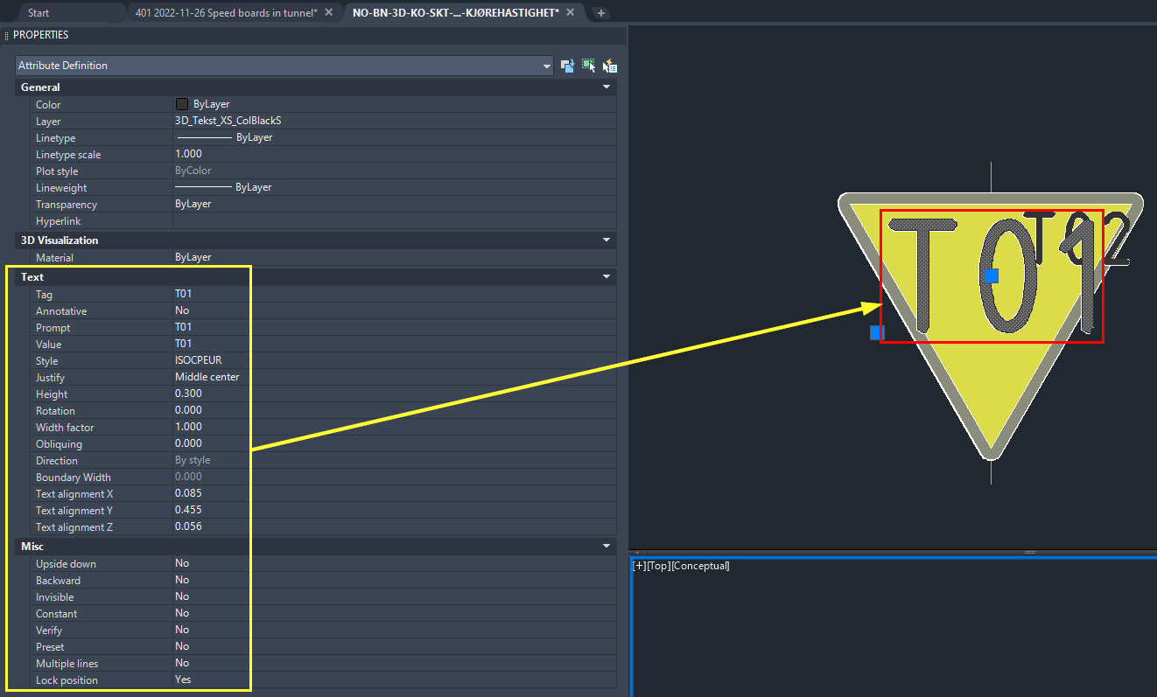

7. Delete the 3D annotation of the ‘4’ speed board, then change SignSpeed to 125 and see that ‘12’ appears on the board, but a smaller ‘5’ also appears. The board’s 3D block has a second ATTDEF entity ‘T02’ to which the ‘5’ from ‘125’ is routed when the 3D export / preview takes place.  
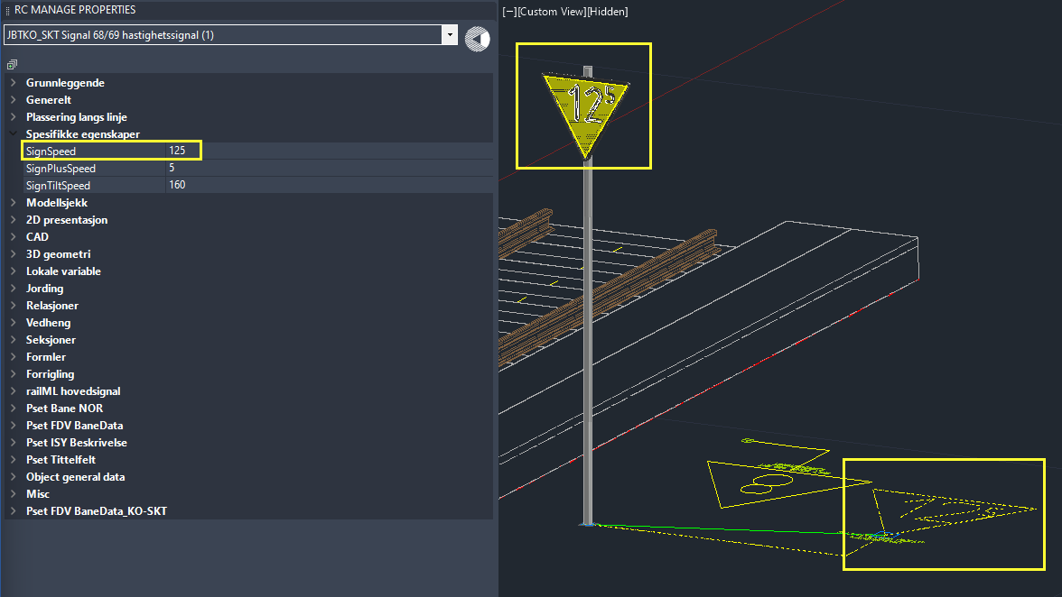

## Changing the board’s pole

8. Open the 3D tab, then open **Model3D_0** (a complex property) and see that the speed board’s **Model3D_0.Offset3D.Z** property is **3.500**. This is the vertical distance from the board’s insertion point (near ‘ground level’) to the 3D offset point where the external 3D file (the speed board) is inserted as a 3D block.  
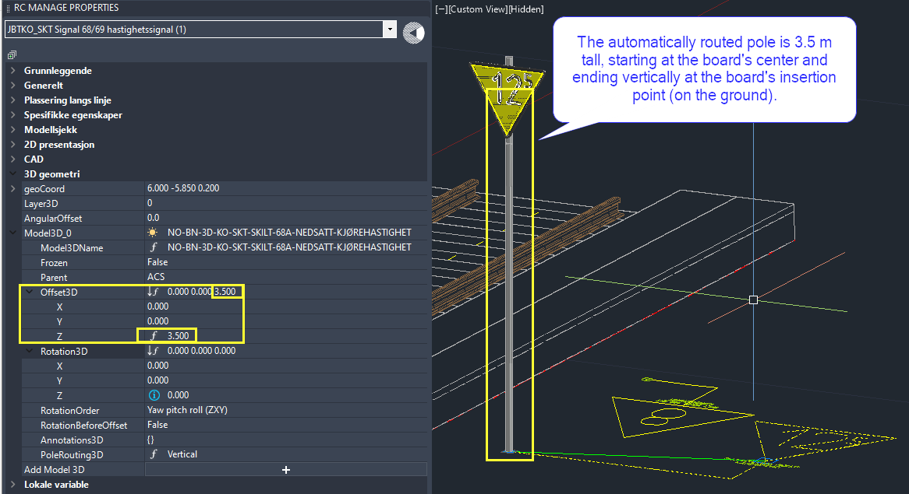

9. Open the Offset3D tab and remove the formula which locks the Z offset to 3.5 (select the Z cell and press DELETE once). You may first inspect the DNA-inherited formula with F3 and expand it with F5, if you are curious to see how the formula decided that ‘3.500’ was our value.  
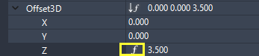

10. The coordinate system being used follows the board’s alignment’s direction of increasing mileage – this is the speed board object’s ACS.[2] Play with different Z offset values, and you will see that the board is moving up and down in 3D preview. Play with different X and Y values, affecting the lateral offset and the longitudinal offset. Play with different rotation values and settings for **RotationOrder** and **RotationBeforeOffset,** to become familiar with their combined effect on 3D preview / export.

## Pole routing

11. Remove the lock on **PoleRouting3D** property (delete the formula), try the different settings and play again with non-zero 3D offsets and non-zero 3D rotations. The pole routing governs whether the pole ends vertically or horizontally at the insertion point or is not drawn at all.  
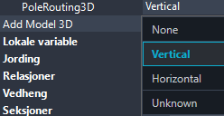

12. How does RailCOMPLETE decide the size, colour and routing of a pole? The information which controls the colour and the size of the circular pole is held in the DWG file for the speed board (in the external 3D folder as installed with your DNA). The basic pole routing information is encoded as a circle and a 3D polyline[3].

13. If pole routing has been enabled, then the circle will be swept along that 3D polyline (if it is there). RailCOMPLETE will by itself also create another 3D polyline which starts at the speed board’s 3D offset point and extends to the speed board’s insertion point[4]. This way, there will always be a vertical pole stub behind the speed board, no matter where the rest of the pole is being routed.  
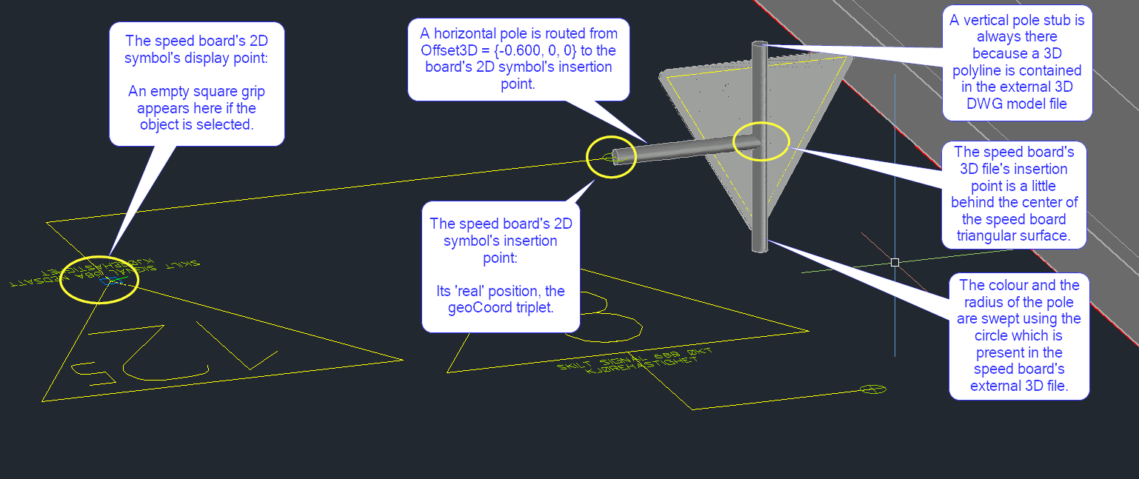

14. Open the AutoCAD layer manager (command **LAYER**) and turn on the layer named ‘_Tunnel’.  
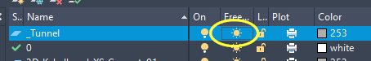  
  
A tunnel appears. Most of the speed boards are located outside the tunnel.

15. We shall mount the speed boards on the tunnel wall, on a ‘knee’ extending towards the closest track. Activate the property manager and 3D preview, then select the speed board of type ‘68A’ belonging to the left track. Change your 3D viewpoint so you see inside the tunnel. Adjust the lateral **Model3D_0.Offset3D.X** to ‘0.800’, adjust **Model3D_0.Offset3D.Z** to ‘0.500’. Remove the locks on **DistanceToAlignment** and **RelativeElevation**, then move[5] the board’s insertion point up on the curved wall. 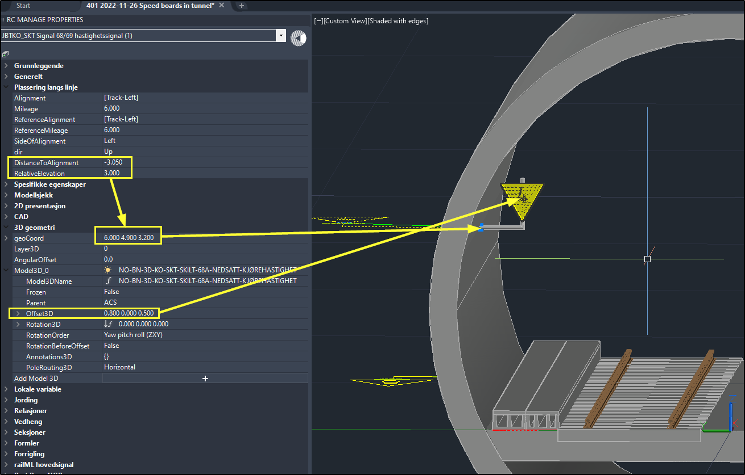

13. Copy the values to the three other boards, with proper signs, to get the completed result:  
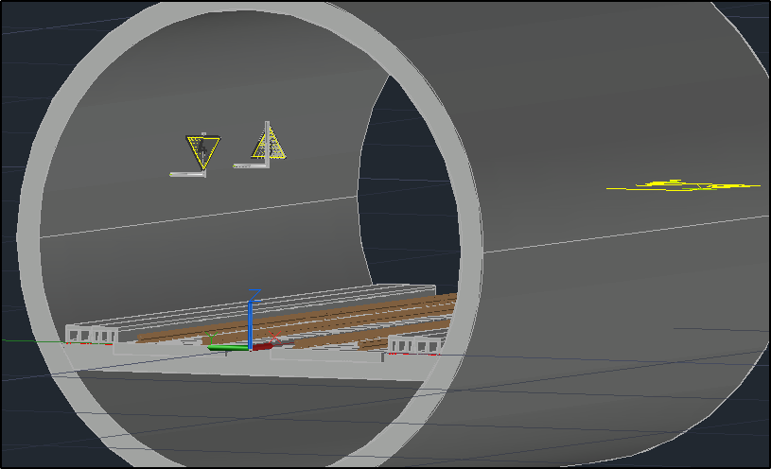

Please check our website www.railcomplete.com for updates.

Corrections and suggestions are welcome to support@railcomplete.com.

Thank you for using RC Tutorials!

1. Your AutoCAD session has probably been started from a Windows shortcut of the type:  
   “C:\Program Files\Autodesk\AutoCAD 2022\acad.exe” /product ACAD /language “fr-FR”, where “fr-FR” means “French language, France’s version”, or similar, or no language specified (English is the native language for AutoCAD). Native AutoCAD commands may have different names in your language pack, other than the COPY, COPYBASE, FIND etc that you see in our tutorial texts. In order to instruct AutoCAD to accept the native English command name, precede the native (English) command name by an underscore character, ‘_’. For instance: ‘_FIND’ will start AutoCAD’s native ‘FIND’ command even if you are using AutoCAD with the French language pack, where the command in French is called ‘RECHERCHER’.If a command needs an argument ‘ON’, and the French menu says ‘Allumer’, then you can enter ‘_ON’ to instruct AutoCAD to use the option’s native name. Furthermore, the English AutoCAD object selection prompt (command _SELECT) accepts many keyboard shortcuts such as A = (add) add to selection set, R = (remove) remove from selection set and AL = (all) all objects (and many more). These shortcuts are named differently in other language packs. In French they are for instance A=ajouter, S=supprimer, TO=tout. Consult AutoCAD Help in your native language.
2. ACS: Alignment Coordinate System: X to the right, Y along increasing mileage, Z straight up, forming a right-handed Cartesian coordinate system. In other words, the unit vector uZ is the cross product of uX and uY.
3. There is also a yellow sphere with radius 0.010 (its diameter is 2 cm), contained on the ‘defpoints’ layer Entities contained on the ‘defpoints’ layer are ignored by AutoCAD when using the **PLOT** command.
4. The object’s insertion point is always held in the property triplet **geoCoord,** expressedin world coordinates.
5. Use combinations of Ctrl/Shift/Alt and your mousewheel on the **DistanceToAlignment** and **RelativeElevation** properties. As they change, the 3D preview tool lets you see directly what the speed board’s resulting position is. Note that if you are quick enough on the mousewheel, then RailCOMPLETE accepts multiple mousewheel “ticks” before the 3D rendering and the general recalculation of the object is remade. If you have a large number of objects, then precious computing time will be saved.